**Dynamic Routing External BGP integration with 2 computers and 2 router**

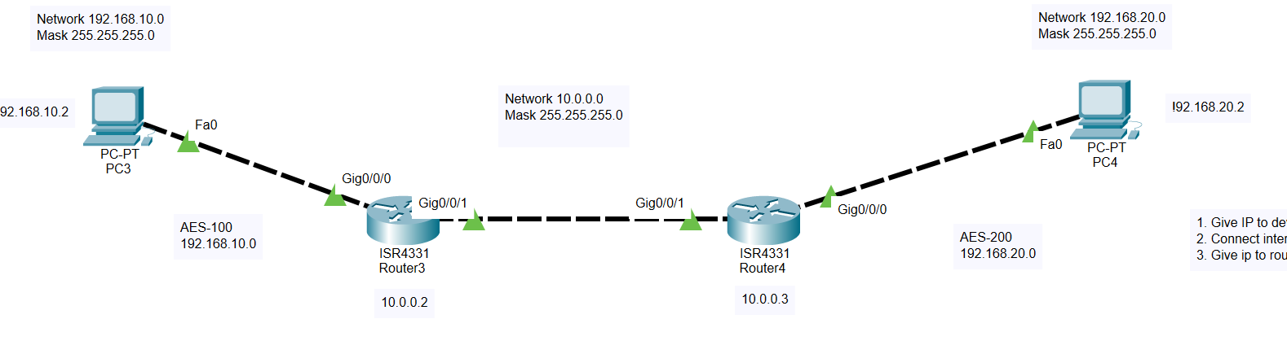

**Task 1: Give IP to pc and routers**

**Task 2: Connect interface of router with pc**

**Task 3: Give IP to router external ports**

**Task 4: BGP configuration on Router 1**

**Task 5: BGP integration on Router 1**

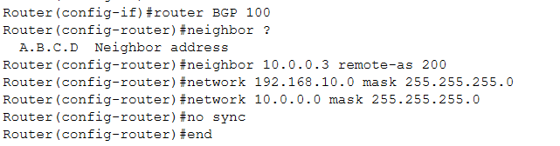

**Task 6: BGP integration on Router 2**

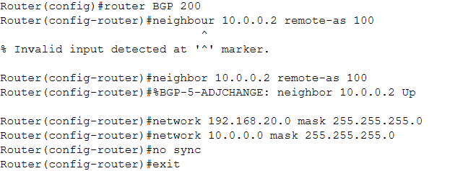

**Ping Test from PC1 to PC2**

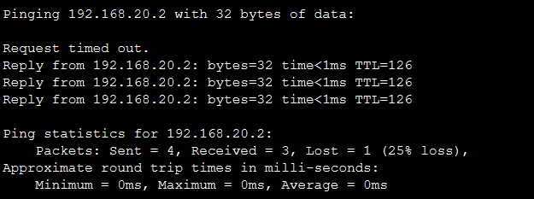

**Ping Test from PC2 to PC1**

